# Cryptography Lab 4

## ECB Mode

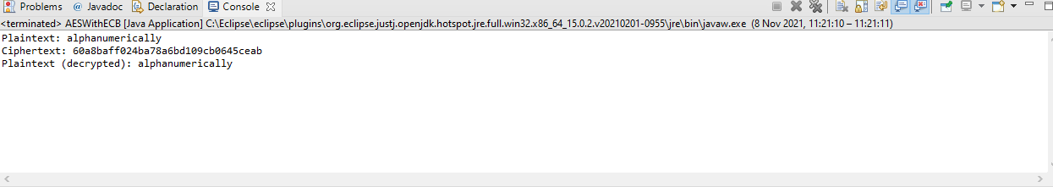

When plaintext is not a multiple

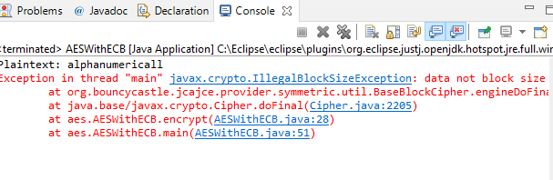PKCS#7 padding

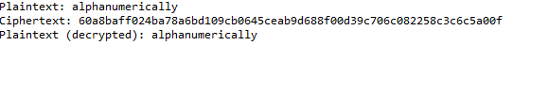

No longer must be multiple

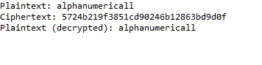

Repeats of strings have the same ciphertext

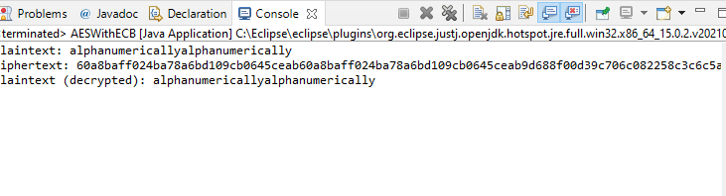

## CBC Mode

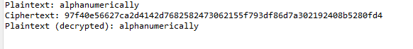

No longer repeats

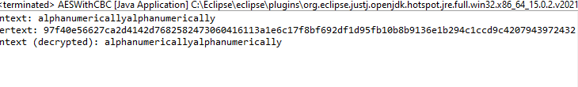

System.out.println(“IV: “ + iv);

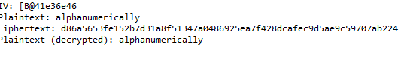

The Ciphertext changes each time

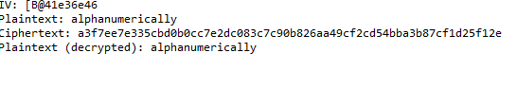

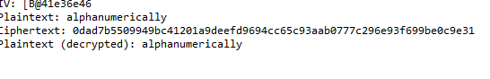

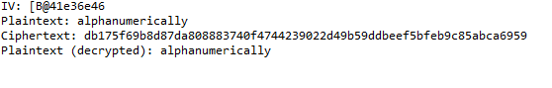

Ciphertext Stealing (Makes it much shorter)

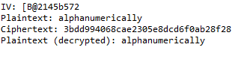

## CTR Mode

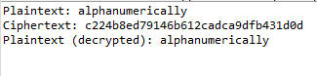

Removing a letter from the ciphertext (lost 2 letters from the ciphertext when lose 1 letter from the plaintext)



Added pkcs7padding, unnecessary though as it works without

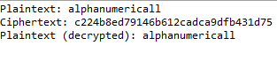

Ciphertext doesn’t repeat when Plaintext Repeats

